Quality Management Program Description

Section: Quality Management
Compliance: URAC Specialty Pharmacy 2.1
URAC Standards: PHARM Core 1, 2, 3, 4, 5, 9, 10, 12, 17, 18, 19, 20, 21, 22, 23, 24, 27, 28, 34, 35, 38, 39, PHARM-OP 1, 14, CSCD 1, 4-13, SDrM 5, PM 1, 2, 3, 4, 5, 8, 13, 19, 20, 21, 22
ACHC Standards: DRX11-A
Policy ID: 8.6
Approved by:

- Organizational Overview

<insert practice name> is an independently owned specialty pharmacy, founded in 20xx that provides services for patients with oncology and hematology medical needs. [PHARM Core 2 (b)][PHARM-OP 1 (a-i)] <insert practice name> focuses the scope of services on those patient populations providing the highest level of service and expertise possible. Currently, <insert practice name> provides services for patients with: oncology/hematology treatments and the various supportive care medications that accompany those conditions. [PHARM-OP 1 (a-i)]

<insert practice name> currently has dispenses medications to the following state: <insert state> [PHARM-OP 1 (a-ii)]

The Governing Body has ultimate authority over the governance of the organization and its programs. Responsibility for the overall leadership and management of <insert practice name> is vested in the physician partners who own the practice. This group is accountable for all operations, for ensuring quality patient care, for ongoing compliance with all local, state and federal regulations and for the ongoing viability of <insert practice name>. On behalf of the Governing Body, the Pharmacy Manager is responsible for maintaining ongoing liaison among the Governing Body, professional advisors and <insert practice name> staff. The pharmacists are delegated day to day operational management. <insert practice name> Pharmacists report directly to the Pharmacy Manager who in turn reports to the Governing Board. The Pharmacy Manager chairs the Quality Management Committee and provides oversight to the organization as a whole. [PHARM Core 1][PHARM Core 18] [PHARM Core 19 (e)]

The Quality Management Program (QMP) reports to the Governing Body. [PHARM Core 19 (a)]

- Quality Management Program Overview

<insert practice name> Quality Management Program helps to ensure <insert practice name> meets its responsibilities to its contractors, patients, and the community through continuous and systematic assessment and improvement of program systems and processes. [PHARM Core 17]

The Quality Management Program is the vehicle through which <insert practice name> analyzes and responds to data collected by its medical record system, claims data, operational performance monitoring, and other program measurement processes. The purpose of the Quality Management Program is to systematically use performance information and data to improve clinical care, training, support and outreach services. [PHARM Core 18]

The Quality Management Program Description (QMPD) outlines the quality management program which promotes objective and systematic measurement, monitoring and evaluation of services and implements quality improvement (QI) activities based upon the findings. The QMPD defines the Quality Management structure and process, as well as the role and responsibilities of the Quality Management Committee, Pharmacy manager, and other staff involved in the execution of the Quality Management Program. The Quality Management Program Description (QMPD) was approved and became initially effective in <Month, Year> when the Quality Management Program was implemented and commenced. The Quality Management Committee reviews the Quality Management Program Description at least annually and updates as necessary. [PHARM Core 19 (a, b, c, d, e]

- Program Scope & Structure

The scope and content of the Quality Management Program is designed to continuously monitor, evaluate and improve the clinical care and service provided to patients and providers by <insert practice name>. [PHARM Core 17][PHARM Core 18] Specifically, the Quality Management Program includes, but is not limited to, the following responsibilities and monitoring of key performance measures: [PHARM Core 19 (b)]

- Development and implementation of the Specialty Pharmacy program [PHARM Core 1]
- Monitoring <insert practice name>’s Performance Improvement Plan [PHARM Core 17]
- Implementation and monitoring of the Patient Management Program [PM 1, 2, 3, 4, 5, 8, 13, 19, 20, 21, 22]
- Monitoring and evaluation of Adverse Drug Event Reporting [SDrM 5 (a, e)]
- Evaluation of accessibility and availability of program representatives [PHARM Core 34]
- Regulatory/Corporate compliance, including HIPAA, current URAC accreditation standards, applicable state and federal regulations, etc. to include standards and procedures to detect and take corrective action for non-compliant employees [PHARM Core 4 (a, b, c)]
- Monitoring for violations regarding Code of Conduct and Conflict of Interest [PHARM Core 4 (b)]
- Establishment and implementation of mechanisms to promote collaboration, coordination and communication across disciplines and departments within organization [PHARM Core 5]
- Oversight of marketing and sales materials [PHARM Core 10 (a, b, c, d)]
- Client (business-to-business) and patient satisfaction surveys regarding program services [PHARM Core 12]
- Management of consumer/client complaints [PHARM Core 35 (a, b, c, d, e)]
- Tracking and follow-up processes for adverse incidents to ensure consumer safety [PHARM Core 38] [SDrM 5 (a, e)]
- Identification, selection, and implementation of Quality Improvement Projects (QIPs) [PHARM Core 20 (g, h)]
- Evaluation and oversight of the performance of delegated entities [PHARM Core 9 (a, b, c)]
- Evaluation of resources to include computer resources, internal staffing etc. and other resources to support day-to-day operations of the Quality Management Program [PHARM Core 18]
- Evaluation of clinical decision support tools as appropriate [PHARM Core 28 (b)]

Oversight and Authority [PHARM Core 19 (a)]

The day-to-day operation of the Quality Management Program is overseen by the Pharmacy manager who is the Senior Clinical Staff Person, and a pharmacist. The ultimate authority for the <insert practice name> Quality Management program is delegated to the Quality Management Committee. The Quality Management Program reports to the Quality Management Committee which is chaired by the Pharmacy manager.

- Quality Management Committee

The Quality Management Committee is granted authority by the Governing Body of <insert practice name> and is responsible for the management of the Quality Management Program. [PHARM Core 20 (a)] This committee meets at least quarterly with the purpose of improving services by monitoring processes, analyzing data, implementing interventions to improve, and evaluating the effectiveness of those interventions. [PHARM Core 20 (c)] The Quality Management Committee receives reports of all monitoring and evaluation activities, maintains records of all committee meetings through minutes taken, which are later reviewed and approved by the committee members. [PHARM Core 20 (d)] The Quality Management Committee receives quarterly reports from the Quality Management Program. [PHARM Core 20 (b)] In order to promote and establish interdepartmental collaboration, coordination and communication across disciplines and departments, the committee members include management and clinical, administrative and marketing representatives who collaborate with participating providers/clients and bring their input to the QMP and Quality Management Committee as applicable.[PHARM Core 5] A participating provider is retained on a consultant basis on an “as needed” basis for participation in the Quality Management Committee when his/her subject matter expertise is required. [PHARM Core 20 (e)] The Pharmacy manager of <insert practice name> is an active member of the committee.

The Quality Management Committee is responsible for the following activities:

- To provide on-going reporting to the Governing Body [PHARM Core 20 (b)]
- To provide guidance to staff on Quality Management priorities and projects [PHARM Core 20 (f)]
- To review and approve the Quality Management Program Description annually [PHARM Core 20 (i)]
- To establish long and short term goals for the Quality Management Program [PHARM Core 19 (b)]
- To review and approve Policies and Procedures at least annually [PHARM Core 3 (a)]
- To measure and monitor the quality of the Patient Management Program to include program based on evidence based medicine in development and reassessment of program. All education materials to be reviewed and authorized annually. Review and analysis of patient outcomes related to formal Patient Management [PM 1, 2, 3, 4, 5, 8, 13, 19, 20, 21, 22]
- To approve selected Quality Improvement Projects (QIPs) [PHARM Core 20 (g)]
- To monitor and document QIPs for progress in meeting QI goals [PHARM Core 20 (h)]
  - To monitor and document key performance measures that are quantifiable and used to establish acceptable levels of performance, including a baseline and at least an annual re-measurement
- Complaints [PHARM Core 21 (b-ii)]
- Patient Satisfaction [PHARM Core 21 (b-iii)]
- Client Satisfaction [PHARM Core 12]
- Monitor access to services to include types of services offered, geographic area served, medication accessibility and availability to patients. To include monitoring availability of nurse evaluation and education when indicated. Also to include monitoring of <insert practice name> Staff responsiveness to telephone activity and office operating requirements [PHARM Core 21 (b-i)] [PHARM Core 34] [CSCD 9 (a, b, c)] [PHARM-OP 1 (a-i, ii, iii b, c)]
- Quality and safety of drug inventory and distribution [PHARM-OP 14 (a-i, b-i, ii, iii, c)]
  - To implement written action plans to improve or correct identified problems or meet acceptable levels of performance [PHARM Core 21 (f)]
  - Evaluate the effectiveness of the Quality Management Program annually [PHARM Core 20 (i)]
  - When applicable, to receive and incorporate input from participating providers [PHARM Core 20 (e)]

The Quality Management Committee will receive the following:

- Reports on progress in meeting Quality Improvement Goals [PHARM Core 20 (h)]
- Analyses of patient complaints and appeals [PHARM Core 21 (b-ii)]
- Analyses of access to services to include phone access, measure performance against types of pharmacy services offered, geographic area served and medication accessibility and availability to consumers [PHARM Core 34]
- Quality management audits to verify on-going monitoring of compliance with CSCD standards [PHARM Core 17][CSCD 1, 4-13]
- Assessment reports of performance related to correct drug, directions, dosage, quantity, patient, labeling to include proper handling and distribution. Assessment of error reporting frequency and completeness to include near misses [SDrM 5 (a, e)]
- Analyses of client and consumer satisfaction surveys [PHARM Core 12][PHARM Core 39]
- Reports on ongoing compliance with URAC standards [PHARM Core 4 (b)]
- Reports on objectives and approaches utilized in monitoring and evaluation of Quality Management activities [PHARM Core 21 (a)]
- Tracking and trending of performance measures relevant to the scope of Specialty Pharmacy [PHARM Core 17]
- Reports on implementation of action plans to improve or correct identified problems [PHARM Core 21 (f)]

- Senior Clinical Staff Role and Responsibilities [PHARM Core 19 (a, e)]

The Pharmacy Manager is the senior clinical person. The Senior Clinical Staff person is an individual who is responsible to provide guidance to the clinical operational aspects of program and provides Quality Management oversight. This individual chairs the Quality Management Committee and is responsible for the oversight of clinical decision-making aspects of the program; he/she also has periodic consultation with practitioners in the field. The Senior Clinical Staff is also responsible to ensure the organization utilizes qualified clinicians who are accountable to the organization for decisions affecting consumers. The Senior Clinical Staff person is a pharmacist and holds a current, unrestricted clinical license in the state of <insert state>. If the license is restricted, <insert practice name> ensures the job functions of this individual do not violate the restrictions imposed by the state licensure board. The Senior Clinical Staff person has postgraduate experience in direct patient care and possesses the qualifications to perform clinical oversight of <insert practice name> services. The Senior Clinical Staff person chairs the Quality Management Committee and the development and implementation of all clinical Quality Improvement Projects.

e. Quality Management Resources [PHARM Core 18]

<insert practice name> employs staff and other resources to provide the necessary support to the day-to-day operations of the Quality Management program. At <insert practice name> all staff take part in the execution of the Quality Management Program. Additionally, the graph below indicates staff who are designated to perform specific Quality Management program tasks and coordinate and oversee Quality Management activities to help ensure the Quality Management program development and plan are enacted.

Staff Title | Dedicated QM FTE
Pharmacy Manager | 0.1 FTE
Pharmacist, Pharmacy technicians | 0.1 FTE
Total Resources | 0.2 FTE

- Quality Improvement Projects

<insert practice name>’s Quality Management Committee identifies areas for improvement from its ongoing monitoring of key performance measures as identified in the Performance Improvement Plan. When an opportunity is identified and the Quality Management Committee determines a formal quality management process is warranted, the Quality Management Committee will select it as a Quality Improvement Project. <insert practice name> will have at least two active QIPs in place at all times that address opportunities for either error reduction or performance improvement related to its Specialty Pharmacy program services. One of the QIPs will address consumer safety. [PHARM Core 20 (f)] [PHARM Core 22] [PHARM Core 24 (a)]

- Quality Management Process Model

The Quality Management Committee is responsible for selecting, implementing and monitoring the progress of all QIPs. The Staff Committee utilizes the PDSA (Plan, Do, Study, Act) process improvement model as outlined in the below graph, to manage the QIP and ensure goals are met and maintained. [PHARM Core 20 (f)]

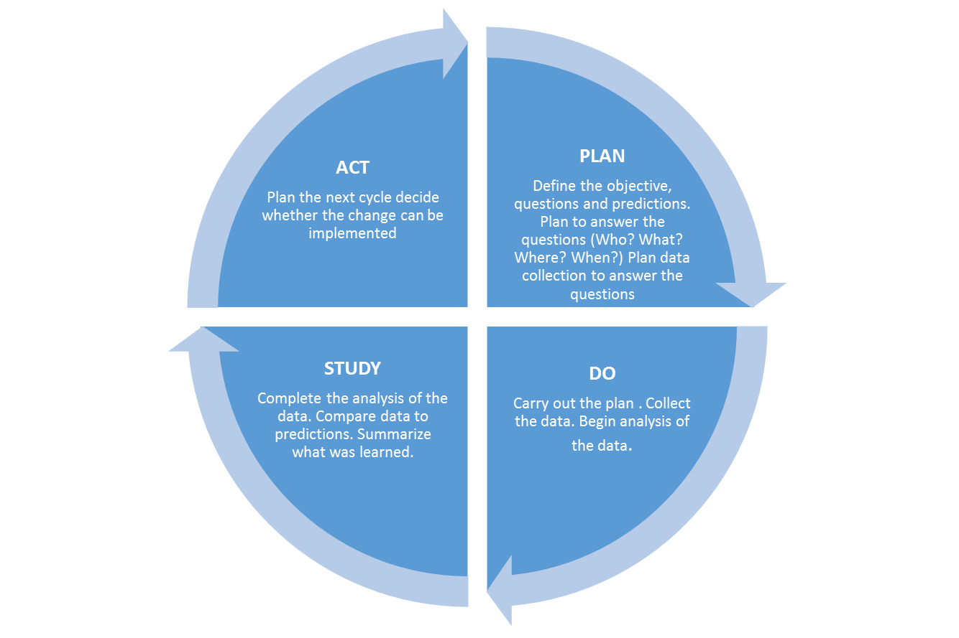

- Quality Improvement Project Structure

The Quality Management Committee ensures that at least one of the selected QIPs addresses consumer safety for the population served. [PHARM Core 24 (a)] If the quality improvement project is clinical in nature, then <insert practice name> will involve senior clinical staff person in judgments about the use of the clinical quality measures and clinical aspects of performance. [PHARM Core 24 (b)] The Quality Management Committee is responsible for gathering, documenting, and reporting all of the following factors for each selected Quality Improvement Project:

- Clearly defined quantifiable measures [PHARM Core 21 (c)][PHARM Core 23 (a)]
- Measure baseline performance [PHARM Core 21 (d)][PHARM Core 23 (e)]
    - Re-measure performance at least annually as compared to the baseline performance [PHARM Core 21 (e)][PHARM Core 23 (d, e)]
- Create specific goals for performance that are an improvement over the baseline performance [PHARM Core 21 (f)][PHARM Core 23 (a)]
- Design and establish strategies for performance improvement [PHARM Core 21 (f)][PHARM Core 23 (b)]
- Documents changes or improvements relative to the baseline measurement [PHARM Core 23 (e)]
- Establish projected time frames for achievement of performance improvement goals [PHARM Core 23 (c)]
- Conduct a barrier analysis if performance goals are not met [PHARM Core 23 (f)]

- Communication of Quality Management Activities

<insert practice name> recognizes the need to involve the whole organization in Quality Improvement. In order to promote quality throughout the organization, the progress on these QIPs as well as other Quality Management activities are routinely communicated to all staff through memos, staff meetings, and bulletins. [PHARM Core 21 (g)] Members of the Quality Management Committee and organization staff are provided with regular updates on QIP performance and quality program goals. [PHARM Core 21 (h)]

- Client Satisfaction [PHARM Core 12]

  - <insert practice name> values input and feedback regarding its programs and services from <insert practice name>’s clients.
  - Mechanisms used by <insert practice name> for collecting information regarding client satisfaction include:

    - <insert practice name> website
    - Client satisfaction surveys
    - Client complaint logs
    - Client meetings

  - Any complaints received follow the same complaint process as the patient complaint process in terms of documentation and follow-up

  - There is also a “contact us” link on the company website.

  - <insert practice name> utilizes client satisfaction information to identify areas of concern and opportunities for improvement. Opportunities are prioritized and corrective action is taken when deemed as needed.

- Patient Satisfaction [PHARM Core 39]

  - Patient Satisfaction is a high priority for <insert practice name>. <insert practice name> conducts monthly or quarterly patient satisfaction surveys are performed by <insert practice name> with completion of mail in or phone surveys by patients or caregivers.

- Clinical Decision and Support Tools [PHARM Core 28 (a, b, c)]

<insert practice name> staff members are trained to utilize several decision support tools to perform their daily tasks. These resources include:

- <insert pharmacy computer system>

  - All staff is trained on the use of <insert pharmacy computer system> for patient care, prescription processing and fulfillment and adjudication of electronic claims.

- Intranet

  - All staff are trained to access <insert practice name> Intranet site for pertinent department information and policies and procedures.

- Colleagues

  - All staff are encouraged to utilize their colleagues and pharmacists for reviewing ideas, sharing best practices and asking for clinical decision support

- Reference Materials

  - <insert practice name> makes various references available in both print and electronic means. (E.g. Drug Facts and Comparisons, Micromedex, Lexicomp, Departmental P&Ps etc.)

- Internet

  - <insert practice name> recognizes that many references are readily available online that are very helpful for staff to utilize in making both clinical and customer care decisions. The utilization of vendor websites on a daily basis to assist with performance of various tasks (i.e. ordering/purchasing, shipping and tracking packaging, general drug information).

- Supervisor/Chain of Command

  - All staff are trained to utilize their supervisors and chain of command when they are unsure of how to answer/handle a particular question/situation.

- All employees are trained on compliance with regulatory and accreditation requirements including the following: [PHARM Core 27 (a, b, c, d)]

  - HIPAA
  - URAC Accreditation Training as appropriate to job function
  - Fraud, Waste and Abuse Training
  - Conflict of Interest Training
  - Confidentiality Training
  - Safety testing on equipment used in the work environment
  - Emergency/Disaster Training
  - Complaints and/or Grievance Procedures
  - Infection Control Training
  - Cultural Diversity
  - Ethics Training
  - Sexual Harassment
  - Work place and client/patient safety-including disaster planning
  - OSHA (Right to Know Laws)
  - Client/Patient Rights and Responsibilities

- Policy and Procedure Adherence [PHARM Core 29 (a, b)]

  - Staff adherence to <insert practice name> Policies and Procedures is evaluated by various means including investigation of complaints re: service, supervisory oversight of daily operations, annual evaluation, etc. Should a situation of non-adherence be identified, corrective action will be taken as outlined in the Corrective Procedure in Employment Manual and/or regulatory compliance policy.

- Health Literacy and Cultural Appropriate Communication Requirements [CSCD 12 (a, b, c, d- i, ii, iii, iv)]

  - <insert practice name> recognizes customer population is very diverse with differing cultural backgrounds, physical needs, literacy levels and languages spoken which may impact the communication with customers. <insert practice name> strives to ensure all patients are treated with respect and in a manner that meets their individual needs. When necessary, <insert practice name> will make necessary accommodations in order to effectively communicate with customers.

DATE: | REVISED BY: | REVISION:

