Change Your AmazonSmile Charitable Organization
On your first visit to AmazonSmile, you're prompted to select a charitable organization from the list of eligible organizations.
You can change your selection at any time.
How to Change your Charitable Organization:
- Sign in to smile.amazon.com on your desktop or mobile phone browser.
- From your desktop, go to Your Account and select the option to Change your Charity. Or, from your mobile browser, select Change your Charity from the options at the bottom of the page.
- Select a new charitable organization to support.
Note: You can also hover over the Supporting notice in the navigation at the top of any page, and then select the Change Link next to the name of the charity you’re currently supporting.
  - Add the Supporting Charity: National Community Oncology Dispensing Association
  - Location: Cazenovia, NY

For more information about the AmazonSmile program, go to http://smile.amazon.com/about.

How to Turn on AmazonSmile in the Mobile App

- Join or Sign in to smile.amazon.com on your web browser. Simply select your favorite charity to start generating donations, at no cost to you.
- Get the app by downloading or updating to the latest version of the Amazon Shopping app on your phone. You can find it in the App Store for iOS or Google Play for Android.
- Turn on AmazonSmile by opening the app and find ’Settings’ in the main menu (☰). Tap on AmazonSmile and follow the on-screen instructions to turn on AmazonSmile on your phone.

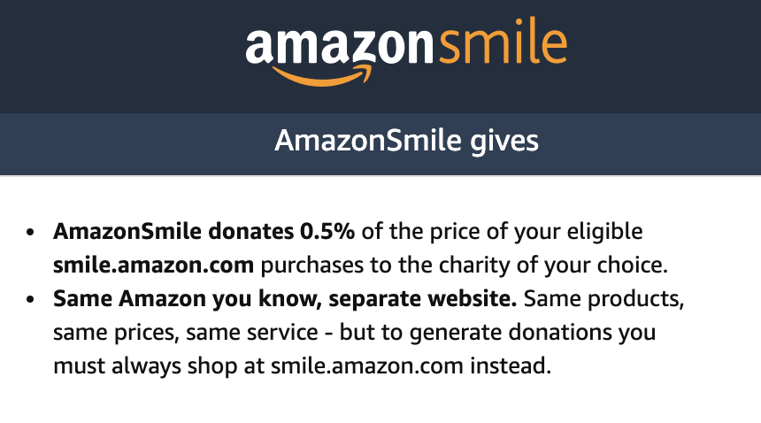
- NCODA participates in Amazon Smile as a charity
- Our goal is to encourage Amazon shoppers that are NCODA members to use Amazon Smile, which will donate 0.5% of the price of eligible purchases to NCODA
- If you already have an Amazon account, it only requires you to sign in through Amazon's Smile portal to set the National Community Oncology Dispensing Association as your charity (see above for assistance)
- You can bookmark AmazonSmile to make all of your normal Amazon purchases with your Amazon login
- It does NOT require a separate login if you already have an account is at no additional cost to the purchaser

