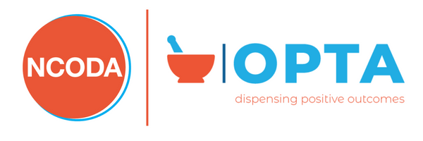

COPT Content Outline

Domain I-Core Oncology Pharmacy Training: 20%

Skills and application to apply necessary oncology pharmaceutical calculation. Practical understanding of pharmacy operation, pharmacy quality assurance, pharmacy safety compliance ordinances and qualified pharmacy accreditation regulations

Knowledge of:
- Pharmaceutical Calculations: BSA, CrCl, mg/kg
- USP 800, storage and handling, spills, PPE, inventory management, Lot/Expiration, Proper disposal
- Basic Standard Operating Procedures purpose/guidelines
- Identifying the major bodies of pharmacy accreditation and their individual standards

Domain II-Clinical Oncology Skills and Patient Management: 30%

Quality improvement through side effect management, adherence, and compliance through assessment and identifying when a pharmacist intervention is required. Description and interpretation of laboratory values associated with oral oncolytics. Comprehension of different diagnostic and interventional radiology studies with understanding and basic translation of findings

Knowledge of:
- CBC
- CMP
- ANC
- Liver functions values
- Tumor Markers and their reference ranges
- PET scan/PET/CT
- CAT scans
- X-rays
- Bone Density
- Bone Scans
- Biopsy, surgery-pathology reports
- Vital signs and their reference ranges
- Grade levels/scales for side effects/adverse reactions
- Oncolytics waring and precautions
- Treatment support kits
- Correct usage of NCODA Resources-OCE, IVE, PQI

Domain III-Oncology Pharmacy Billing: 20%

Recognition and comprehension of different healthcare plan to accurately process oral oncolytic as determined by indication and diagnosis. Efficiently process and obtain prior authorization, and financial assistance if needed.

Knowledge of:
- Oncolytic Billing, billing per cycle, quantity, and day supply
- Insurance verification
- Identify all parts of Medicare, Federal Plans
- Medicare Part B, Medicare part B Drugs, specific billing rules, regulations, and compliances
- Medicare Advantage
- Tri-Care/Tricare Prime
- Medicaid and Low-Income subsidy
- Commercial Plans
- Medical Billing vs. Pharmacy Billing
- Navigating patient assistance options
- Prior authorization procedure

Domain IV-Oral Oncolytics: 30%

Appropriately identify oral oncolytics by brand/generic name, indication and correct dosing for treatment

Knowledge of:
- Oral Oncolytics-Brand names, Generic names
- Strengths, directions per indication, dosing, and administration
- Dose adjustments: Adverse events, decrease weight
- Indication of Oncolytics including supportive prescriptions medications/OTC medications

